PT Scheme – 19 round

TEST TASK No. 1

**THE WORK OF AN ANALYST WITH A VOLUMETRIC FLASK**

The purpose of the test is to evaluate the work of the analyst who conducts routine tests for compliance with the requirements of Normal Analytical Practice (NAP) (see the SPhU, 5.3.N.2. Validation of analytical procedures and tests, Table 4.2). The assessment is carried out based on the results of handling a test volumetric flask with a capacity of 100.0 ml. The procedure of analyst testing simulates the operation of a volumetric flask in routine analysis.

Each participant in the PT round is provided with a test volumetric flask with a certified value of the volume contained. The analyst conducts 5 determinations of the filling volume of the flask according to the following procedure (gravimetric method of determining the volume).

The obtained results will be evaluated according to the following parameters:

1) Precision of filling the volume of the flask with the analyst to the mark.

*Criterion*: the standard deviation (SD) of five successive volume determinations should not exceed 0.034 ml (the criterion used by the SPhU in establishing the NAP requirements for volumetric flasks [[1]]).

Compliance with the criterion is established by the PT organizer.

2) Deviation of the contained volume from the certified volume of the flask.

*Criterion*: The deviation of each of the five flask volume measurements from the certified value shall not exceed the requirements of the NAP [[2]]. Compliance with the criterion is established by the PT organizer.

The PT organizer invites participants (analytical laboratories) to involve in the testing from one to five analysts, at the discretion of the laboratory, and to provide the results for each analyst separately. In this way, the laboratory will be able to assess the qualifications of analysts performing routine tests.

During the test, the analyst should handle the flask as in a routine analysis. See ISO 4787 Laboratory glassware — Volumetric instruments — Methods for testing of capacity and for use, chapter 10. The stage of turning the flask upside down during testing is not performed, the volume of the flask is brought to the mark from the bottom up. In order to ensure a correct evaluation of the results during testing, certain conditions and parameters specified in the given procedure must be observed and controlled.

**Testing Procedure**

1. **Instruments, equipment, and materials.**
   1. **Balances**. The metrological characteristics of the balances must satisfy the following requirements:

* Resolution ≤ 1 mg;
* Repeatability ≤ 2 mg;
* Expanded uncertainty during use ≤ 4 mg

The balance weighing range should allow for weighing a flask filled with water.

* 1. **Measurement equipment**.

The minimum requirements for measurement equipment are specified in Table 1.

Table 1.

Minimum requirements for measurement equipment

|  |  |  |
| --- | --- | --- |
| **Equipment** | **Resolution** | **Expanded Uncertainty U (k = 2)** |
| Water Thermometer | 0.1 °C | 0.2 °C |
| Air Thermometer | 0.1 °C | 0.2 °C |
| Hygrometer | 1% relative humidity | 5% relative humidity |
| Barometer | 0.1 kPa | 1 kPa |

* 1. **Calibration Liquid**. Use degassed water, for example, *carbon dioxide-free water R*, or another degassing method.

1. **Determining the contained volume**
   1. Before the test, the flask, all test equipment, and water shall have stood in the test room for a sufficient time to reach equilibrium with the test room conditions, the temperature variation of the room during this time should not be more than 1 0C per hour. The equilibration time is usually about 2 hours and can be longer.

Test water should be covered to avoid evaporation cooling.

At the start of the test, the flask should be dry.

* 1. The humidity of the air shall be recorded:

The test room shall have a relative humidity (RH) between 30 % and 80 %.

* 1. Atmospheric pressure shall be recorded.
  2. Weigh the dry flask – m0.
  3. The air temperature in the room shall be recorded.

The test room shall have a temperature between 17 °С and 23 °С with a maximum variation of ± 1 °С during the test.

* 1. Fill the flask to the graduation mark with water and weigh – mfull_i.
  2. Determine the mass of water in the flask – mi.
  3. The water temperature in the flask shall be recorded. Place the mercury bulb or temperature sensor below the flask's neck in the rounded part. Before this, remove excess water to minimize contact with the flask walls above the graduation mark.
  4. Proceed as per steps 2.5 – 2.8 repeating the procedures 5 times.
  5. Calculate the results:
* the volume contained in the flask – Vi, found.
* deviation of the contained volume from the nominal – ΔVi (accuracy of value to two decimal places).

1. Calculations formulas.

* 3.1. The volumetric capacity (Vi, found) is calculated using the following formula:

$$V_{i,found}=\frac{m_{i}}{ρ_{w}-ρ_{a}}×\left(1-\frac{ρ_{a}}{ρ_{b}}\right)×[1-γ(t-20)]$$

where:

𝑖 - is the sequential number of the parallel determination;

𝑚𝑖 - is the mass of water in the flask in grams;

𝜌𝑤 *-* is the density of water at the measurement temperature in g/ml;

𝜌𝑎 *-* is the density of air at the measurement temperature and atmospheric pressure in g/ml;

𝜌b *–* is the **density of the material of the balance weights (for electronic balances, a standard value of 8.0 g/ml is assumed);**

𝛾 - is the coefficient of cubic thermal expansion of the flask material in °C−1 (for the test flask, 9.9×10−6 °C);

𝑡 - is the temperature of water during the measurement in °C.

* + 1. The density of water within the temperature range from 17 °C to 23 °C is calculated using the following formula:



Where:

𝜌𝑤 - is the density of water at the measurement temperature in g/ml.

𝑡 - is the temperature of the water in °C.

* 1. The deviation of the volumetric capacity of the flask from the nominal is calculated: by:

$$∆V_{i}=V_{i,found}-100$$

Table 2*

**Air density (ρa 103), in grams per milliliter, within the temperature range from 10 to 30 °C and absolute pressure from 930 to 1040 mbar.**

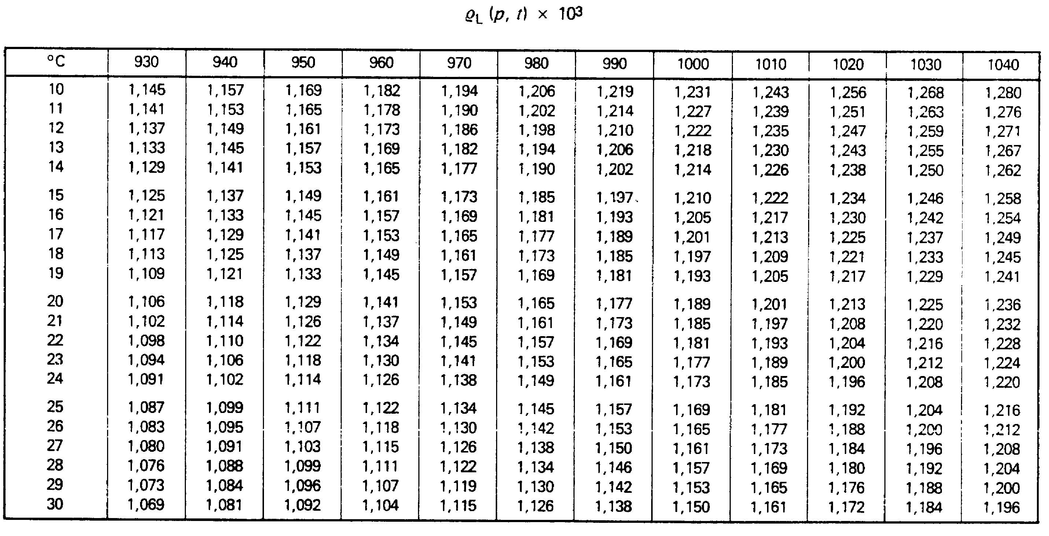

_______________________________

**\*When using the table, round the values of temperature and pressure during the experiment to those specified in the table**

PTS - 19 Round

Results of Test Task No № 1

**Work of an analyst with a volumetric flask**

|  |  |
| --- | --- |
| **Laboratory name** |  |
| **Head of the laboratory** |  |
| **Analyst** |  |
| **Date of testing** |  |

**Materials and equipment used:**

|  |  |  |  |  |  |  |
| --- | --- | --- | --- | --- | --- | --- |
| **Balance** | | | | | | |
| Model and manufacturer of balance |  | | | | | |
| Specifications | Resolution, mg | Repeatability,  mg | | | **Expanded Uncertainty**,  mg | |
|  |  | | |  | |
| Date of metrological verification |  | | | | | |
| Was balance qualification carried out? | □ Yes ________________ (Date) □ No | | | | | |
| **If "Yes": Qualification Parameters and Acceptance Criteria** | Parameter | | Acceptance criteria | | | Value |
|  | |  | | |  |
| … | | … | | | … |
| **Thermometer** (for measuring water temperature) | | | | | | |
| Model and manufacturer |  | | | | | |
| Resolution of thermometer |  | | | | | |
| Date of metrological verification |  | | | | | |
| Expanded uncertainty of thermometer |  | | | | | |
| **Thermometer** (for measuring air temperature)) | | | | | | |
| Model and manufacturer |  | | | | | |
| Resolution of thermometer |  | | | | | |
| Date of metrological verification |  | | | | | |
| Expanded uncertainty of thermometer |  | | | | | |
| **Testing liquid** | | | | | | |
| What degassing method was used? |  | | | | | |
| **Volumetric flask** | | | | | | |
| Was a visual inspection of the flask carried out before testing? | □ Yes □ No | | | | | |
| If *“Yes”,* by what parameters? | Parameter | | | Result of inspection | | |
|  | | |  | | |
|  | | |  | | |
| Was the flask washed before testing? | □ Yes □ No | | | | | |
| If *“Yes”,* briefly describe how. |  | | | | | |

**Measurement results:**

|  |  |  |  |
| --- | --- | --- | --- |
| **Air temperature during the equilibration of the flask and equipment with the environment:** | *Time,*  *hour: min* | *Air temperature, ºC* | *Gradient, °С/hour* |
| Start of observations |  |  | *−* |
| + 1 hour |  |  |  |
| + 2 hours |  |  |  |
|  |  |  |  |

|  |  |
| --- | --- |
| Relative humidity, % |  |
| Atmospheric pressure, mbar |  |

|  |  |  |  |  |  |  |
| --- | --- | --- | --- | --- | --- | --- |
| Measuring the mass of water and calculating the contained volume | | | | | | |
| *№* | *Air temperature, ºC* | *Water temperature, ºC* | *Mass of empty flask (m0), g* | *Mass of flask with water (mfull_i), g* | *Found contained volume, Vi, found, ml* | *Deviation of contained volume from nominal, ΔVi, ml* |
| 1 |  |  |  |  |  |  |
| 2 |  |  |  |  |  |
| 3 |  |  |  |  |  |
| 4 |  |  |  |  |  |
| 5 |  |  |  |  |  |

Head of laboratory _________________________________/_________________

(Signature)

1. . Quality assurance of the results of analysis during basic operations of sample preparation: volumetric flasks. Komarova Yu.A., Leontiev D.A., Gryzodub O.I. // Farmakom. – 2014. - №1. – Р. 48-57. <https://sphu.org/wp-content/uploads/2017/01/Farmacom_1_2014.pdf>
2. . 5.3.N.2 Validation of analytical procedures, section 4.5 // the State **Pharmacopoeia of Ukraine / Ukrainian Scientific Pharmacopeial Center for Quality of Medicines. – 2nd edition. – Addendum 6. – Kharkiv: State enterprise “Ukrainian Scientific Pharmacopeial Center for Quality of Medicines”, 2023. – 422 p.**